Classic Wooden Sailboat for Sale

25’ Friendship Sloop – Schoodic

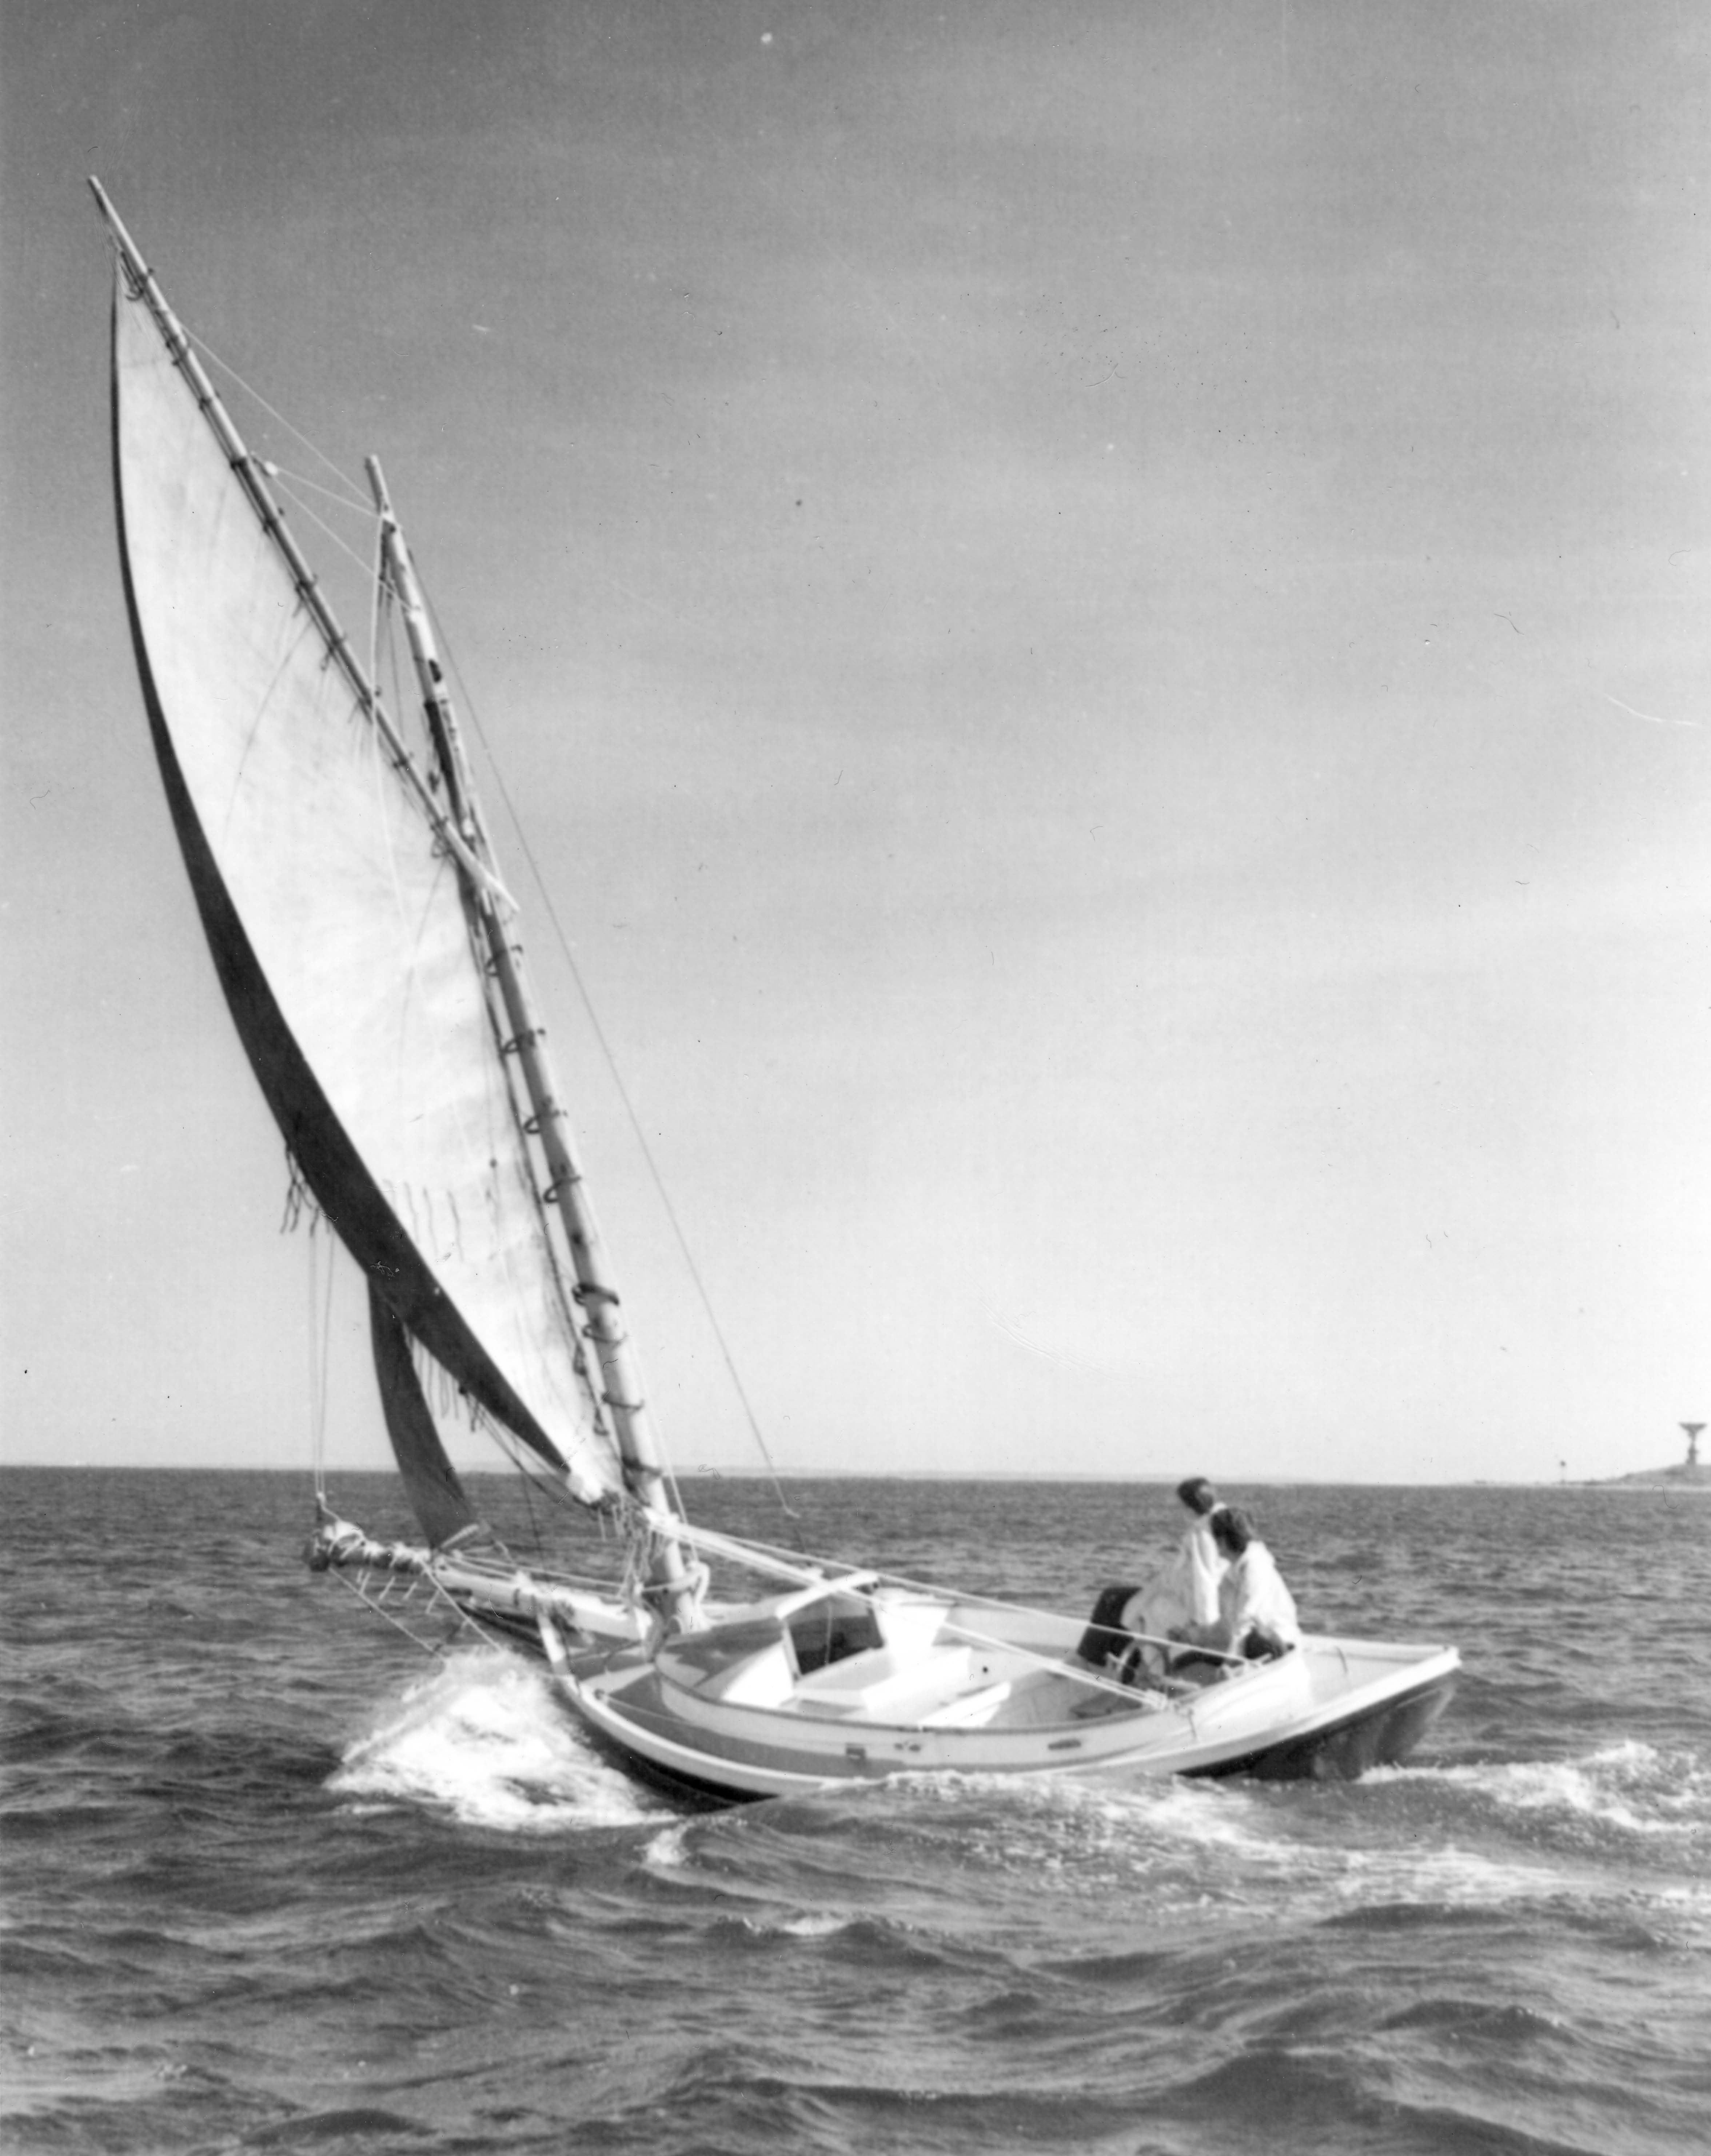

Year built: 1967 by Concordia Co., Dartmouth Mass.
Designer: R.D. “Pete” Culler
Dimensions: LOD 25’ 6” ; LWL 21’ 2” ; LOA 38’ 6”
Construction: Carvel cedar planks on white-oak frame
Cost: $12,500 or best offer
Location: Portsmouth, NH
Contact: John Mayer
jmayer.nh@gmail.com
(603) 422-9551
or
Bob Barth
(603) 659-0380

Details: Classic wooden sailboat in excellent condition. Built in 1967 using traditional standards for materials and workmanship. Schoodic is a day-sailer, with no modern systems or engine.

Canvas sails (2005) made by Gamble and Hunter. New canvas deck (2007).
6/1/08

